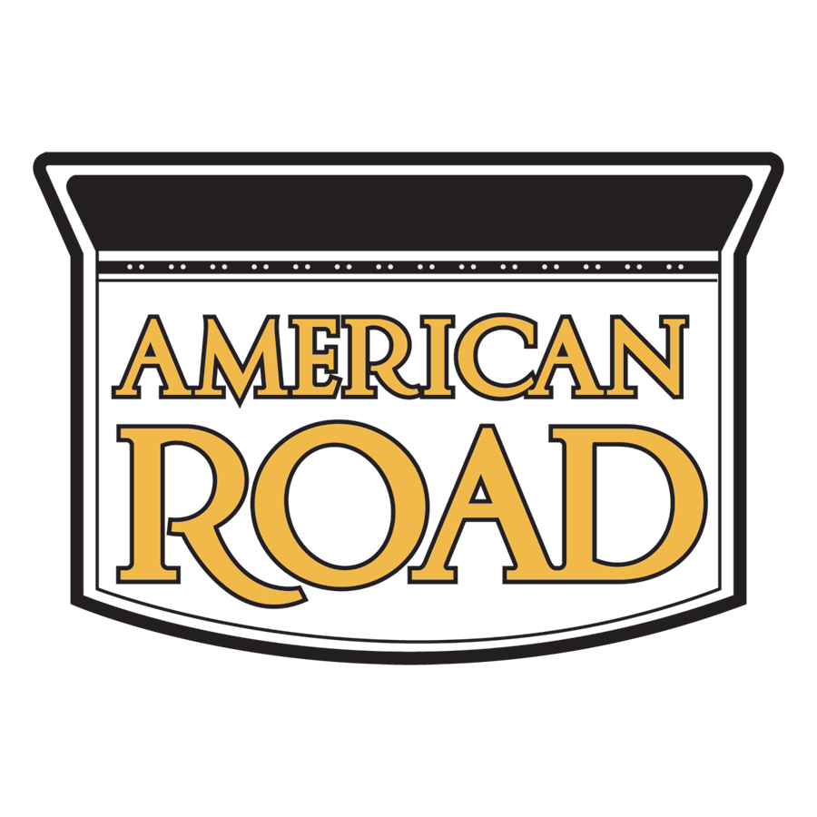

AMERICAN ROAD Magazine
P.O. Box 46519
Mt. Clemens, MI 48046
1-877-285-5434

AMERICAN ROAD “COLOR OUR COVER” Photo Contest Rules SPONSOR
Sponsor and host: is AMERICAN ROAD magazine, P.O. Box 46519, Mt. Clemens, MI 48046 USA ("Sponsor" or "ARM"). Additional sponsors: Oregon’s Mount Hood Territory, the City of West Wendover.

TERM

The American Road “Color Our Cover” Photography Contest (the “Contest”) begins at 12:01 a.m. US Eastern Time on February 12, 2023, and ends at 11:59:00 p.m. US Eastern Time (“ET”) on April 30, 2023. Information about prizes and how to enter the contest form part of the contest rules (“Contest Rules”). By submitting an entry, each individual agrees to the Contest Rules and warrants that his or her entry complies with all requirements established in the Contest Rules. This is a skill-based contest. Chance plays no part in the determination of winners.

WHO MAY ENTER

The Contest is open to anyone who does NOT reside in Crimea, Cuba, Iran, North Korea, Sudan, Russia, China, or Syria and WHERE OTHERWISE PROHIBITED. Contestants under the age of majority in their jurisdiction must provide documented parental permission. Employees of AMERICAN ROAD magazine, and its subsidiaries and affiliates, and their immediate family members—spouse, parent, child, sibling and their respective spouses, regardless of where they live—or persons living in the same households of such employees, whether or not related, are not eligible.

HOW TO ENTER
Each entry consists of a completed entry and a single image of an official coloring page. To enter, visit https://www.americanroadmagazine.com/fun-games/coloring-contest/, and complete the contest form with the required information—your name, address, telephone number, email address, age range (using the age at the time of entry) and caption. Submit the form along with your digital file in accordance with the following instructions:

Limit: There is a limit of one entry per person. Each entry must comply with the following requirements:

Select, download, print, and color (using crayons, pastels, or colored pencils) an official American Road cover coloring page for 2023. Once done, simply complete our registration form and scan or take a photo of your work. Upload your high-resolution coloring page image. Guidelines:

Coloring pages must be in digital format. Only online entries will be eligible. All digital files must be in JPEG or JPG format, and must be at least 2550 pixels x 3319 pixels. PLEASE KEEP THE ORIGINAL COLORING PAGE, as the editorial team may request the original or a higher resolution scan if there are problems with the digital file.

You can help us celebrate our 20th anniversary of AMERICAN ROAD MAGAZINE too. If you'd like to share your entries on social media, post them with the hashtag #ARmag20years, and we may share your post on our pages (you still have to register and upload to officially enter the contest).

Winning coloring pages may be featured in an upcoming publication.
Prizes include:
• First place in each category wins a $100 gift card.
• All finalists will receive a subscription to AMERICAN ROAD.
The entries MUST BE ONE OF THE APPROVED CONTEST COLORING PAGES and will be judged separately, in accordance with the Judging Criteria, as defined below. All entries must be submitted and received by April 31 at 11:59:00 p.m. ET. Proof of submission is not proof of receipt. The sponsor reserves the right to examine the original source material in order to confirm compliance with these rules.

Winners of AMERICAN ROAD's Coloring Contest and Giveaway may be featured in an upcoming publication. Plus, first place in each age category wins a $100 gift card.

RELEASES

Upon Sponsor's request, each entrant (or legal guardian) must be prepared to provide (within ten (10) calendar days of receipt of Sponsor's request) a signed release authorizing Sponsor and its licensees ("Authorized Parties") to reproduce, distribute, display, and create derivative works of the entry in connection with the Contest and promotion of the Contest, in any media now or hereafter known. Failure to provide such releases upon request may result in disqualification at any time during the Contest and selection of an alternate winner.

Requests will be sent via email. For the purposes of these Contest Rules, the entrant will be deemed to be in receipt of Sponsor's request or notification, on the day that the email was sent by Sponsor. CONTEST PRIZES

A Grand Prize winner in each category will receive a prize package including a gift card worth $100.

No prize transfer, assignment, or substitution by winners permitted. If a prize (or part of a prize) is unavailable, the Sponsor, in its discretion, reserves the right to substitute the original prize (or that part of the prize) with an alternative prize of equal monetary value and/or specification, unless to do so would be prohibited by law.

JUDGING

A panel of American Road staff will select a finalist from all eligible entries based on the following criteria (“Judging Criteria”): Creativity (50%) and Use of Color (50%)—in accordance with the contest theme. In the event of a tie, the tied entries will be re-submitted to the Judges for a re-judging between the tied entries alone. In the event that a tie remains after re-judging, the entry with the highest score in the creativity criteria will be declared the winner. Winner(s) will be chosen on or around June 10, 2023, and will be notified by email. Winners will be announced on americanroadmagazine.com, social media channels as well, including: Facebook, Twitter, Instagram, etc. Decisions of the judges are final and binding.

LICENSE

By entering the Contest, all entrants warrant that he/she is the artist and grants an irrevocable, perpetual, worldwide non-exclusive license to Authorized Parties to reproduce, distribute, display and create derivative works of the entries (along with a name credit) in connection with the Contest and promotion of the Contest, in any media now or hereafter known, including, but not limited to: Display at a potential exhibition of winners; publication of a book featuring select entries in the Contest; publication in American Road magazine or online, highlighting entries or winners of the Contest.
Entrants consent to the Sponsor doing or omitting to do any act that would otherwise infringe the entrant’s “moral rights” in their entries. Display or publication of any entry on an Authorized Party’s website does not indicate the entrant will be selected as a winner. Authorized Parties will not be required to pay any additional consideration or seek any additional approval in connection with such use. Additionally, by entering, each entrant grants to Authorized Parties the unrestricted right to use all statements made in connection with the Contest, and pictures or likenesses of Contest entrants, or choose not to do so, at their sole discretion. Authorized Parties will not be required to pay any additional consideration or seek any additional approval in connection with such use.

LIMITATION OF LIABILITY

By entering this Contest, all entrants agree to release, discharge, and hold harmless American Road magazine and its partners, affiliates, subsidiaries, advertising agencies, agents and their employees, officers, directors, and representatives from any claims, losses, and damages arising out of their participation in this Contest or any Contest-

related activities, and the acceptance and use, misuse, or possession of any prize awarded hereunder.

American Road assumes no responsibility for any error, omission, interruption, deletion, defect, or delay in operation or transmission of entries or entry forms, or of: communications line failure; theft or destruction of, or unauthorized access to Contest entries or entry forms; or alteration of entries or entry forms. American Road magazine is not responsible for any problems with or technical malfunction of any telephone network or lines, computer online systems, servers or providers, computer equipment, software, or failure of any email entry to be received on account of technical problems; traffic congestion on the Internet or at any website; human errors of any kind; or any combination thereof, including any injury or damage to entrants' or any other persons' computers related to, or resulting from participation, uploading or downloading of any materials related to this Contest.

CONDITIONS

THIS CONTEST IS VOID WHERE PROHIBITED. Entrants agree that this Contest shall be subject to and governed by the laws of Michigan and the forum for any dispute shall be in Michigan, United States of America. To the extent permitted by law, the right to litigate, to seek injunctive relief, or to make any other recourse to judicial or any other procedure in case of disputes or claims resulting from, or in connection with this Contest are hereby excluded, and any entrant expressly waives any and all such rights. Certain restrictions may apply. Entries are void if the Sponsor determines the photograph to not be an original, or if the entries are illegible, incomplete, damaged, irregular, altered, counterfeit, produced in error, or obtained through fraud or theft.

By entering, entrants also agree (a) to be bound by these Contest Rules; (b) that the decisions of the Judges are final and binding with respect to all matters relating to the Contest; and (c) if the entrant wins the Sponsor may use the winning coloring page and each winner's name, photograph, likeness, and/or voice in any publicity or advertising relating to the Contest or future promotions without compensation or approval (except where prohibited by law). All federal, state, provincial, territorial, and local taxes, fees and surcharges and taxes (whether foreign or domestic, and including income, sales, and import taxes) on prizes are the sole responsibility of the prize winners. In the event that the selected winner(s) of any prize is/are ineligible, cannot be traced, or does/do not respond within ten (10) days to a winner notification, or refuse(s) the prize, the prize will be forfeited and Sponsor, in its sole discretion, may choose whether to award the prize to another entrant.

The Sponsor reserves the right to verify the validity and originality of any entry and/or entrant (including an entrant's identity and address) and to disqualify any entrant who submits an entry that is not in accordance with these Contest Rules or who tampers with the entry process. Failure by the Sponsor to enforce any of its rights at any stage does not constitute a waiver of those rights.

RIGHT TO CANCEL OR SUSPEND CONTEST

If for any reason the Contest is not able to run as planned, due to infection by computer virus, bugs, worms, trojan horses, denial of service attacks, tampering, unauthorized intervention, fraud, technical failures, or any other causes beyond the control of American Road magazine that corrupt or affect the administration, security, fairness, integrity, or proper conduct of this Contest, American Road magazine reserves the right, at its sole discretion, to disqualify any individual(s) who tamper with the entry process, and/or to cancel, terminate, modify, or suspend the Contest. If Sponsor elects to cancel or terminate the Contest, Sponsor will not retain any rights to the submitted photographs.

WINNERS LIST

Entrants are responsible for complying with these Contest Rules. The winner(s) names may be published in the Spring 2023 issue of American Road magazine.

DATA PRIVACY

Entrants agree that personal data, especially name and address, may be processed, shared, and otherwise used for the purposes of, and within the context of the Contest and any other purposes outlined in these Contest Rules. The data may also be used by the Sponsor in order to verify the participant's identity, postal address, and telephone number, or to otherwise verify the participant's eligibility to participate in the Contest. Entrants have the right to access, review, rectify, or cancel any personal data held by Sponsor by writing to American Road magazine at P.O. Box 46519, Mt. Clemens, MI 48046. Personal data will be used by Sponsor and its affiliates exclusively for the purposes stated herein.

NOTICE TO INDIVIDUALS: REMOVAL FROM MAILING LIST: Any individual (or
other duly authorized person) may elect to exclude the name and address of that individual from all lists used by American Road to mail skill contests or sweepstakes. To elect to have an individual's name excluded from all such lists, submit a removal request in writing to: American Road, PO Box 46419, Mt. Clemens, MI 48046. This notification system may be used to prohibit mailing of all skill contests or sweepstakes by American Road to such individual.

